SQL Server Process Kill when SPID utilizing for memory and disk space.

Step 1
- Execute the below query to identify which SPID has been blocking.
- Then execute the KILL command with SPID.
SELECT
session_id AS SPID,
blocking_session_id AS BlockingSPID,
wait_type,
wait_time,
status
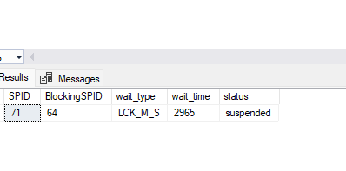

KILL <SPID>;

Step 2
- Execute the below query and after execution list of SPID and Commands running currently.
- To find which CPU time and DISK IO is high and status is Sleeping.
- EXEC sp_who2;
- Then execute KILL command with SPID which is high CPUtime , DISKIO and status Sleeping.
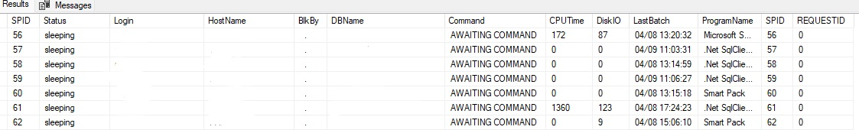

KILL <SPID>;

